Network Battery Monitoring(NBM) Document

Version 1.0

### 

### 

### 

### 

### 

### 

### 

### 

### DEVELOPED BY

DUK PANHAVAD (BATCH3)

Table of Contents

**Introduction** **3**

Document Purpose 3

Scope of document 3

Definitions, acronyms, and abbreviations 3

References Document 3

**Hardware overview** **4**

Hardware usage 4

Voltage Divider Circuit 4

Hardware case 5

**Software overview** **6**

Use-Case diagram 6

**Cost of Production** **7**

**Project Output** **7**

Network Battery Monitoring V1.0

JUN 27, 2019

### COMPANY - Dexpertize

### Projects - Network Battery Monitoring V1.0

Members:

Duk Panhavad

This is written to make understand of how this project created.

In order to get internet connection to supply the whole vKirirom resort, network department is totally dependent on internet signal received by an antenna placed on the top of the mountain which can not supply electricity there by wire. So network department decided to use solar panel and battery but there were certain problem that cause the lost of internet supply to vKirirom such as Battery is empty without knowing. So this project is created to solve that problem by monitoring the battery power remotely.

During the initial creation of the **Network Battery Monitoring V1.0** we are targeting a specific goal to achieve in this version such as:

* Live monitoring of each battery power
* Alert to the responsible person when the battery power reaches a certain level
* Able to transfer battery information through ethernet
* 60% of the programming configuration should be able to customize through network.

Finally, after all the hard work, and the help from network department team. I am able to understand what the problem is, what they need, and what are all the constraints I have to handle during do the project. On 12 October 2019 Network Battery Monitoring V1.0 was indoor tested and satisfy by Mr.Nget Phanny.

Yours Truly,

Duk Panhavad

# 

# 

# 

# Introduction

This section gives a scope, description and overview of everything have to be done in this project.

## **Document Purpose**

The purpose of this document is to give a detailed description of the requirements for the “Network Battery Monitoring”. It will illustrate the purpose and complete declaration for the development of system. It will also explain system constraints, interface and interactions with other external applications. This document is primarily intended to be a reference for developing the first version of the system for the developer.

## **Scope of document**

From the very beginning, the lost of battery power at anata without knowing in advance cause so much problem to vKirirom Staff, Student, Customer and Security. So this project will be so helpful to solve those problems.

By notifying the responsible person in advance before those batteries run empty. This will be so useful for battery replacing problem since currently if the battery runs empty it might take nearly 3hours to prepare everything and fully replace those batteries.

While the responsible get notify in advance, any action that will have to perform in order to change the battery will be prepare in advance too. So this will bring vKirirom internet to 99.99% downtime.

## **Definitions, acronyms, and abbreviations**

* **NBM** - Network Battery Monitoring
* **Arduino UNO** - is an open-source microcontroller board based on the Microchip ATmega328P microcontroller and developed by Arduino.cc
* **Arduino Ethernet Shield** - allows an Arduino board to connect to the internet
* **Blynk** - IoT platform to connect your devices to the cloud, design apps to control them, analyze telemetry data, and manage your deployed products at scale

## **References Document**

* <https://www.arduino.cc>
* https://blynk.io

# Hardware overview

## **Hardware usage**

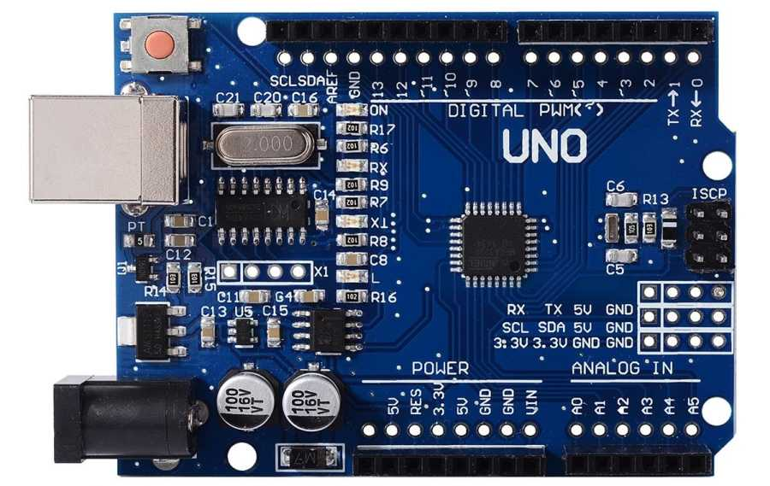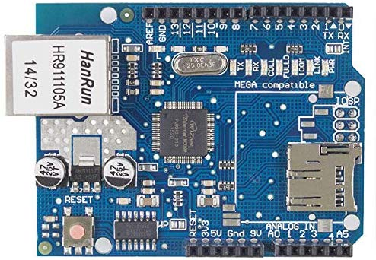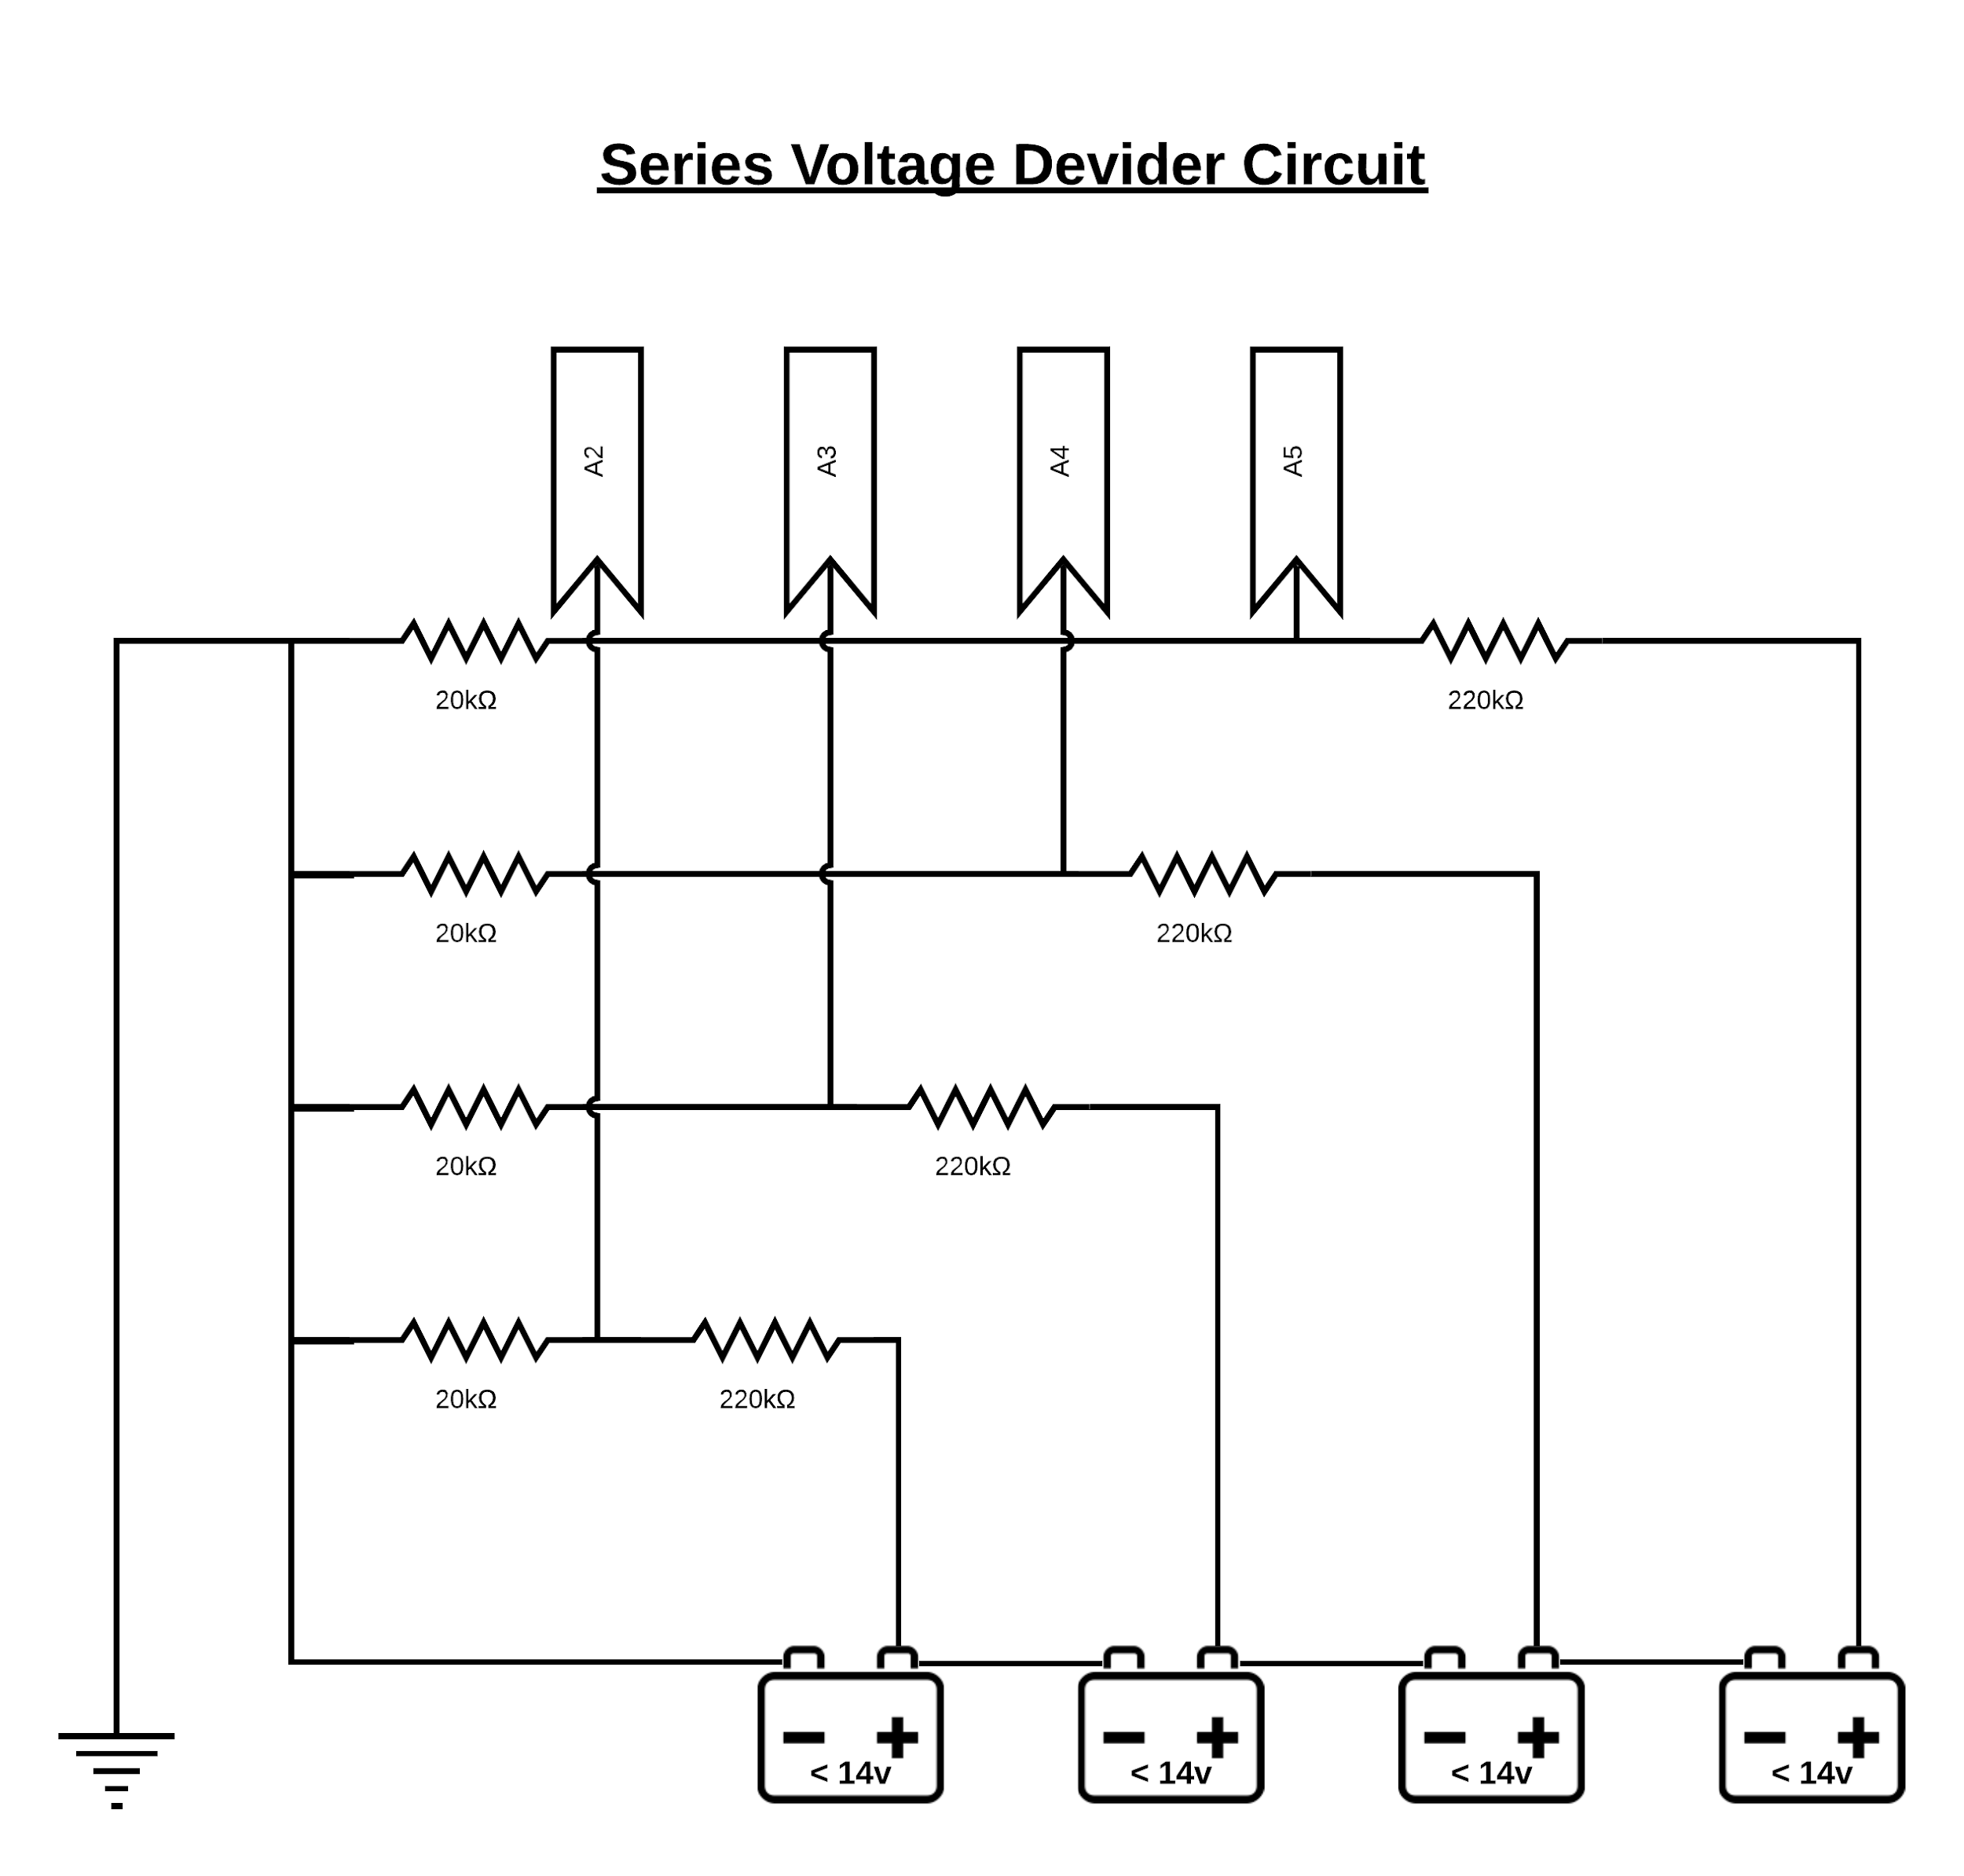

* Arduino UNO (Chiness Version)
* Arduino Ethernet Shield W5100
* Customize Series Voltage Divider

## **Voltage Divider Circuit**



* 1. **Circuit Connection**

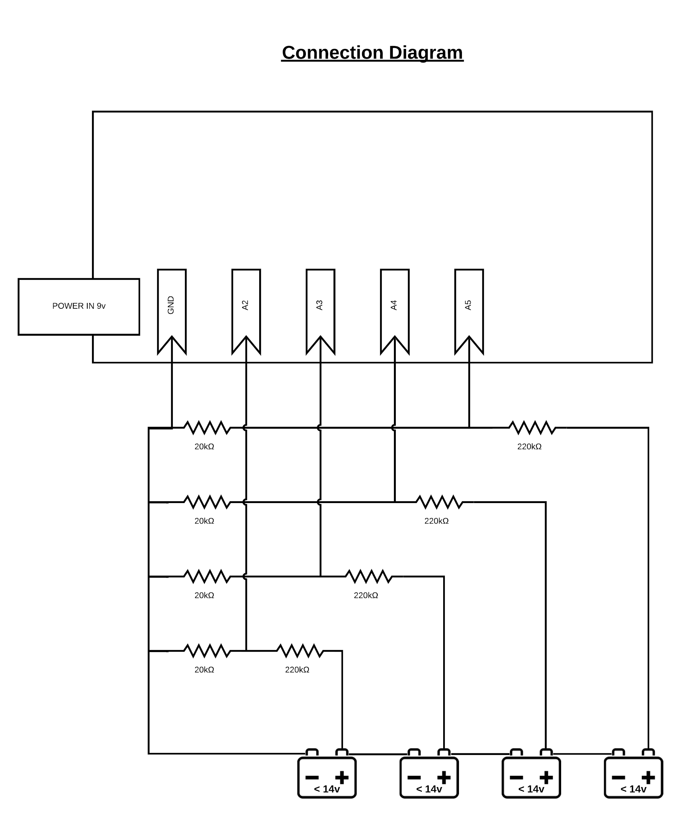

## 

## **Hardware case**

Link to 3D model: [case_modeling](https://drive.google.com/drive/folders/1mzTB_Wjy93GVwVte1kKjALP6ZSL0zM3l)

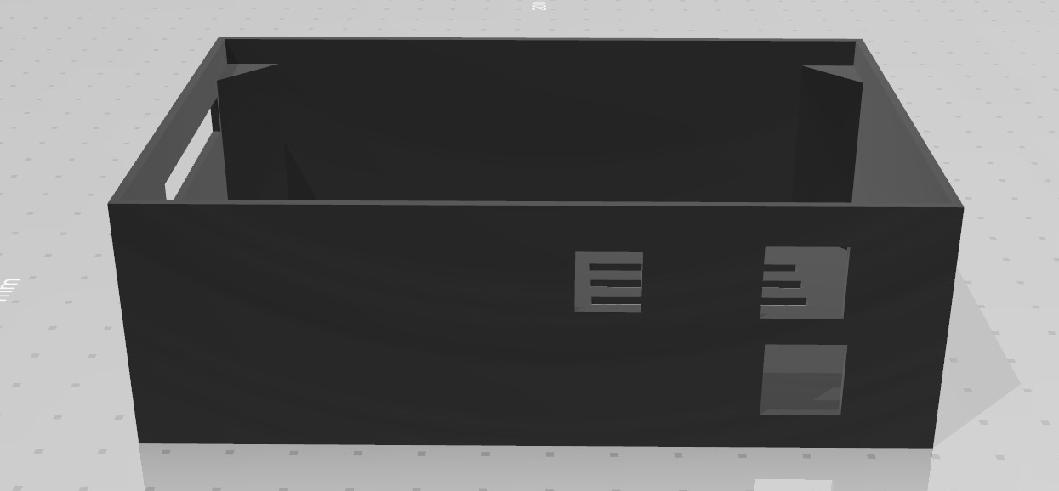

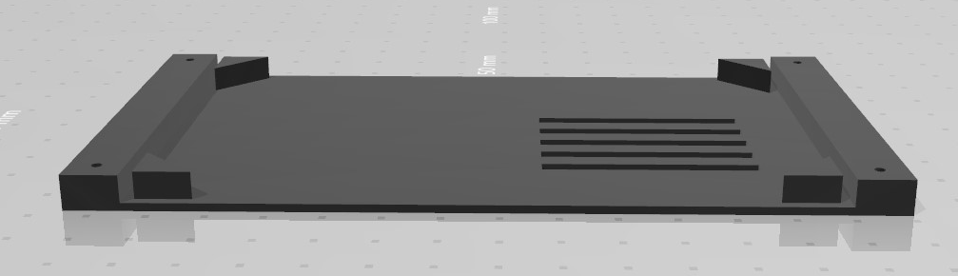

# Software overview

* 1. **Software Usage**



* Arduino IDE (Free)
* Blynk App (Free)
* Blynk Local Server (Free)

## **Use-Case diagram**

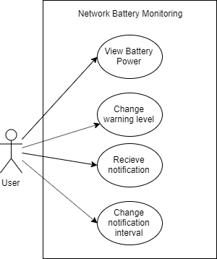

* 1. **Source Code (Private)**

Link to GitHub Repository: <https://github.com/panhavad/network_battery_monitoring>

# Cost of Production

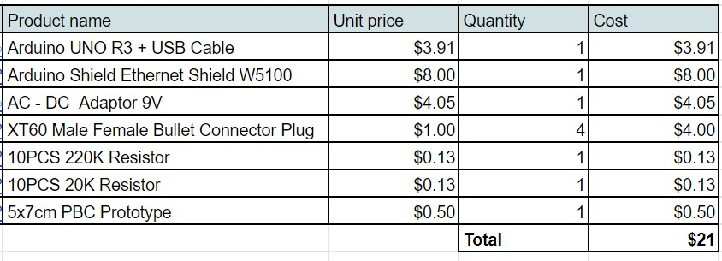

# Project Output

